Design of Software Systems, Products, and/or Processes. In this part of the study, the researchers explain the system's framework and design, which includes the functions and procedures of the system to give readers a better understanding of the system's capabilities and potential. The system's design focuses on the integration of modules to deal with the challenges of footwear retail operations.
Hierarchical Input-Process-Output. To identify the functions of the system and its components, the researchers utilized the HIPO diagram. The HIPO diagram is an analysis tool that shows the sub-functions of the system and the flow of data through the input, process, and output components. The main function of the system is to support footwear retail operations through customer shopping and services (Module 1.0), seller operations (Module 2.0), virtual fitting and 3D visualization (Module 3.0), orders, payments, and fulfillment (Module 4.0), and admin and system administration (Module 5.0). The diagram shows the input components supplied by customers (account and foot-size data, search and product selections, cart and checkout data, payment proofs, chats, and customization requests), by sellers (store applications and documents, products, variants, inventory, .glb models, order decisions, POS transactions, and GCash verifications), and by admins (approvals, moderation actions, banners, vouchers, and audit entries). The process components validate entries, apply business rules, and write to the Supabase tables (profiles, customer_addresses, foot_measurements, products, product_variants, inventory, cart_items, orders, order_items, payment intents, gcash_payment_proofs, sales_transactions, customization_requests, conversations, messages, notifications, and audit logs). The output components are the created or updated records, screens, timelines, receipts, previews, and notifications shown in Figures 4, 4a, and 4b below.
Figure 4
Hierarchical Input-Process-Output
LEVEL | MODULE / SUB-PROCESS | ROLE / OWNER
0.0 | CUFMAI: Footwear Retail Management System with Virtual Fitting Support | All roles
1.0 | Customer Shopping and Services (1.1-1.6) | Customer
2.0 | Seller Operations (2.1-2.7) | Seller
3.0 | Virtual Fitting and 3D Visualization (3.1-3.4) | Customer / Seller
4.0 | Orders, Payments, and Fulfillment (4.1-4.5) | System
5.0 | Admin and System Management (5.1-5.5) | Admin
Each Level-2 sub-process is detailed in the Input-Process-Output tables in Figures 4a and 4b. Current scope: Flutter app (customer/seller/admin shells) + React Admin Portal + Supabase (Auth, Postgres, Storage, Realtime, FCM push).
Figure 4a
Input-Process-Output Diagram (Part A): Registration, Login, Profiles, and Seller Approval.
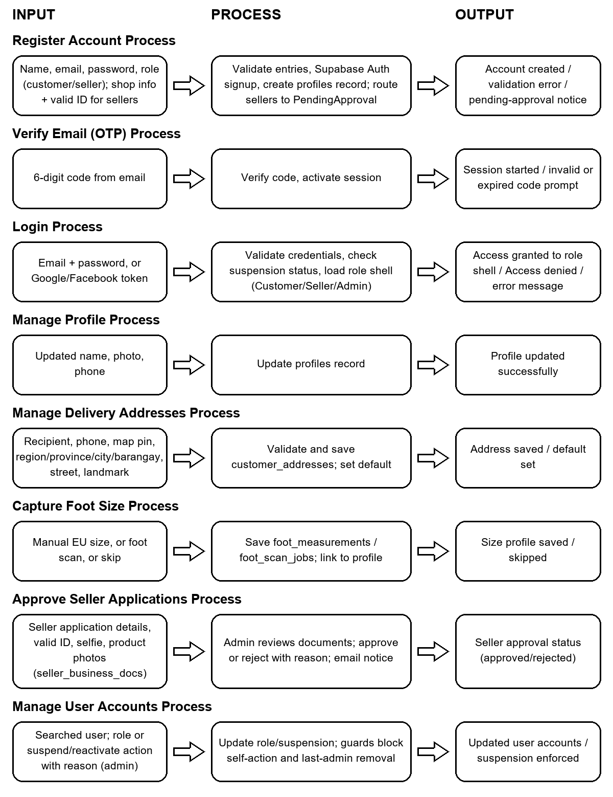
Figure 4b
Input-Process-Output Diagram (Part B): Catalog Browsing, Virtual Fitting, Cart, and Checkout.
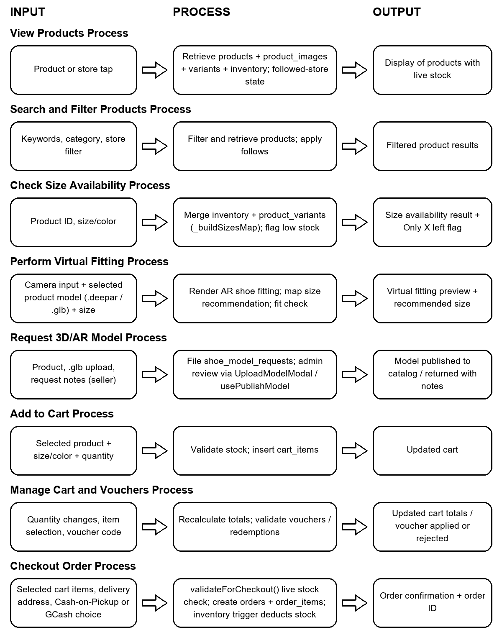
Figure 4c
Input-Process-Output Diagram (Part C): Payments, Products, Inventory, Orders, and Point of Sale.
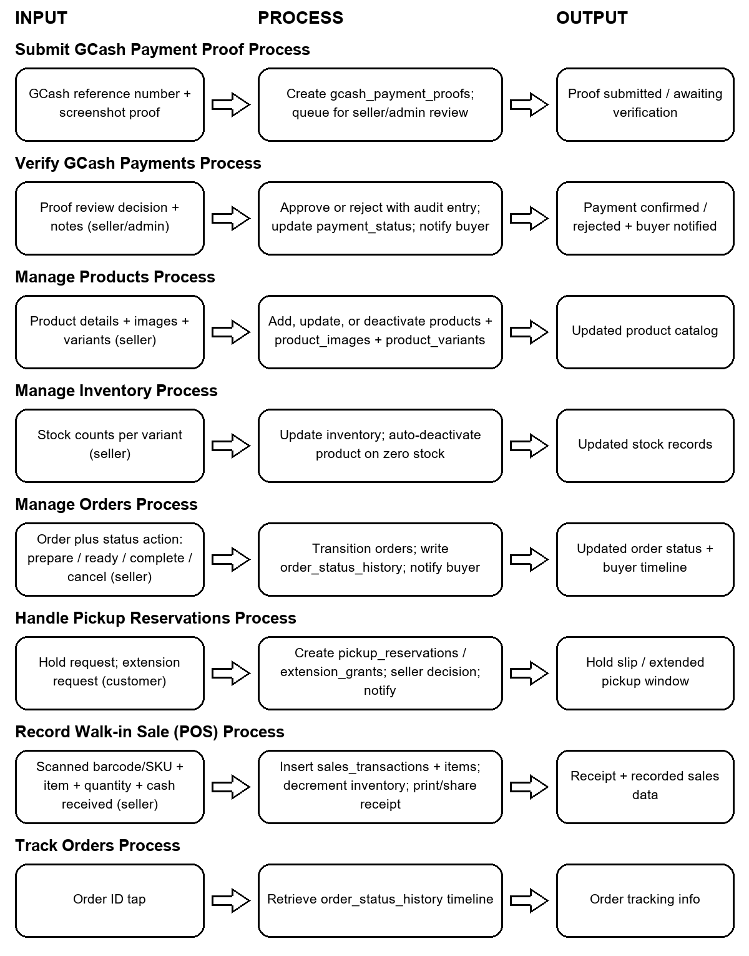
Figure 4d
Input-Process-Output Diagram (Part D): Reviews, Chat, Notifications, and Administration.


